Exercise 16

- List ids, birth dates and email of employees born in April.
SELECT e_id, birth_date, p_email FROM employee_per WHERE MONTH(birth_date) = 4;
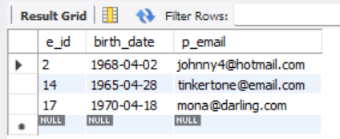
- Display ids, birth dates and spouse names of employees born in 1969 and sort the entires on the basis of their spouse names.
SELECT e_id, birth_date, s_name FROM employee_per WHERE YEAR(birth_date) = 1969 ORDER BY s_name ASC;
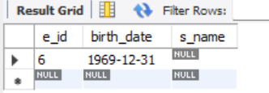
- List the employee ids for employees born under the current month.
SELECT e_id FROM employee_per WHERE MONTH(birth_date) = MONTH(CURDATE());
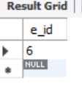
- How many unique nirth years do we have?
SELECT COUNT(DISTINCT YEAR(birth_date)) AS unique_birth_years FROM employee_per;
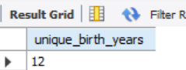
- Display a list of unique birth years and the number of employees born under each.
SELECT YEAR(birth_date) AS birth_year, COUNT(*) AS num_employees FROM employee_per GROUP BY YEAR(birth_date) ORDER BY birth_year ASC;
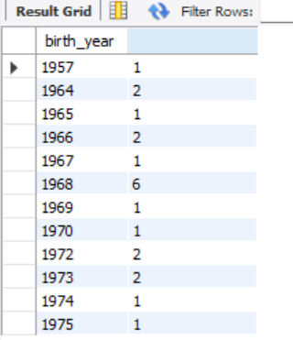
- How many employees were born under each month? The display should have month names(Not numbers) and the entries should be sorted with the month having the largest number listed first.
SELECT MONTHNAME(birth_date) AS month_name, COUNT(*) AS num_employees FROM employee_per GROUP BY MONTH(birth_date), MONTHNAME(birth_date) ORDER BY num_employees DESC;
